



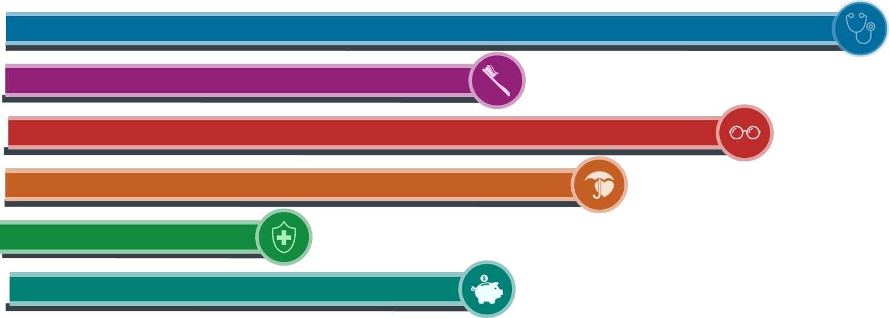

**2024**

**Kurtz Bros, Inc.**

**Enrollment Guide**

# WELCOME TO YOUR 2024 BENEFIT GUIDE!



We are dedicated to providing you with unique benefits that meet the needs of you and your family. We understand the importance of a well-rounded benefits program, and because of that, we offer a range of plans that help protect you in the case of illness or injury. You can learn about the details of these plan options by reading through this Benefit Guide.

Starting with the basics of how to enroll, followed by the details of each plan, this guide is a go-to resource for all things benefits related. Once you better understand the various options we offer, you can make an informed decision on which plans work best for you and your family.

We encourage you to read through this booklet in its entirety. Included you will find details about:

* Who is eligible to participate
* How to enroll and how to make changes during the year, if applicable
* Each benefit offered and a summary of what is covered under the plan
* The Insurance Companies who administer our benefits and how to contact them if you need assistance
* And much more!

We appreciate the hard work and dedication you bring to our company. For this and many other reasons, we want to offer you competitive and cost effective benefits. It’s one way we can say thank you for your contributions.

If you have any questions about the employee benefits described herein or would like more information, please refer to your plan documents and insurance booklets or contact the Human Resources Department.

Sincerely,

Your HR Team

The information in this Enrollment Guide is presented for illustrative purposes and is based on information provided by the employer. The text contained in this Guide was taken from various summary plan descriptions and benefit information. While every effort was taken to accurately report your benefits, discrepancies or errors are always possible. In case of discrepancy between the Guide and the actual plan documents the actual plan documents will prevail. All information is confidential, pursuant to the Health Insurance Portability and Accountability Act of 1996. If you have questions about your benefits, contact Human Resources.

Please see page 14 under *Important Notices* for information on the Medicare Part D Notice.

Jackie Repicky, [Jackie.repicky@kurtz-bros.com](mailto:Jackie.repicky@kurtz-bros.com) 440-487-3208

Tiffany Bean, [tiffanyk@kbbioenergy.com](mailto:tiffanyk@kbbioenergy.com) 216-469-9800

|  |  |
| --- | --- |
| people | WHO IS ELIGIBLE?  If you are a full-time employee (working 30 or more hours per week) you are eligible to enroll in the benefits described in this guide. Spouse, domestic partner, and dependents are eligible for medical, dental and vision coverage. |
| form | HOW TO ENROLL  Login to: **eselfserve.com**  **Username** & **Password** are what you use to login normally to the app.  **If you need your username or password reset, please contact HR.**  Once you’ve logged in, you can click on Open Enrollment through the To-Do or Tasks section on the right-hand side or under the Benefits tab. Click on the Green banner and walk-through enrollment step-by-step! Be sure to add your dependents – this will adjust your benefit offerings accordingly. For example, if you have a spouse in the system, it will show coverage options for employee only and employee + spouse. Confirm your benefits at the end to complete enrollment! |
|  | WHEN TO ENROLL  The open enrollment period is **November 1 – November 12**. The benefits you elect during open enrollment will be effective from January 1, 2024 through December 31, 2024. If you do not enroll or opt out of coverage, you will automatically be enrolled in Employee Only coverage on the Basic Plan. |
| changes | HOW TO MAKE CHANGES  Unless you have a qualified change in status, you cannot make changes to your benefit elections until next year’s open enrollment period. Life events such as marriage, divorce, birth or adoption of a child, change in child’s dependent status, death of qualified dependent, change in employment status or change in coverage under another employer-sponsored plan may qualify you for a special enrollment period. Please notify HR within 30 days of your qualifying event. |

The chart below provides an overview of your available medical plans. Please refer to your plan document for specific details. Below outlines your plan options through UMR and Smith Rx.

|  |  |  |  |  |
| --- | --- | --- | --- | --- |
|  | **1500 Option** | **2500 Option** | **3200 HSA Option** | **5000 Option** |
| Services | **In-Network** | **In-Network** | **In-Network** | **In-Network** |
| **Deductible**  **- Individual - Family** | $1,500  $3,000 | $2,500  $5,000 | $3,200  $6,000 | $5,000  $10,000 |
| **Coinsurance**  **- Plan Pays - You Pay** | 80%  20% | 70%  30% | 100% Covered After Deductible | 70%  30% |
| **Out-of-Pocket Max**  (including deductible, copay & coinsurance)  **- Individual**  **- Family** | $3,000  $6,000 | $7,150  $14,300 | $4,000  $8,000 | $7,150  $14,300 |
| **Primary Care Visit** | $15 Copay Adults,  $0 Copay Children | $15 Copay Adults,  $0 Copay Children | Deductible &  Coinsurance | $15 Copay Adults,  $0 Copay Children |
| **Specialist Visit** | $50 Premium Designated, $100 All Other Providers | $50 Premium Designated, $100 All Other Providers | Deductible &  Coinsurance | $50 Premium Designated, $100 All Other Providers |
| **Telemedicine** | $0 Copay | $0 Copay | $49 Copay | $0 Copay |
| **Urgent Care** | $15 Copay | $25 Copay | Deductible & Coinsurance | $25 Copay |
| **Emergency Room** | $300 Copay | $300 Copay | Deductible & Coinsurance | $300 Copay |
| **Preventative Care** | 100% Covered | 100% Covered | 100% Covered | 100% Covered |
| **Prescription Drugs**  **- Generic**  **- Preferred Brand**  **- Non Preferred Brand**  **- Specialty** | $10  $35  $70  $70 | $10  $35  $70  $70 | After Deductible  $10  $35  $70  $70 | $10  $35  $70  $70 |

**YOUR COST**   
Your payroll deductions are shown below.

|  |  |  |  |  |
| --- | --- | --- | --- | --- |
| **Bi-WEEKLY EMPLOYEE DEDUCTIONS** | | | | |
|  | **Employee Only** | **Employee & Spouse** | **Employee & Children** | **Employee & Family** |
| **1500 Option** | $184.62 | $406.15 | $332.31 | $551.54 |
| **2500 Option** | $120.00 | $265.38 | $233.08 | $360.00 |
| **3200 HSA Option\*** | $99.23 | $218.31 | $178.62 | $296.77 |
| ***\*HSA Employer Annual Contribution*** | $675 | $1,050 | $1,300 | $1,600 |
| **5000 Option** | $83.52 | $183.75 | $150.35 | $249.74 |

Free **generic** medications and **insulin products**, shipped to your home!

RX ‘N Go is an optional mail-order pharmacy program for generic & insulin medications - These medications are **$0 copay and $0 delivery cost!** There are approximately 1,300 generic maintenance & insulin medications available through Rx ‘n Go. Medications are 100% paid for by your employer and mailed to you at no cost! By using RX ‘N GO, you can receive up to a 90-day supply of certain medications that treat conditions such as cholesterol, diabetes, hypertension, emotional health, asthma, and more, as written by your doctor.



HOW TO SIGN UP FOR RX ‘N GO?

**To check if your medication is available through RX ‘N GO, follow the steps below**

1. Go to [www.rxngo.com](http://www.rxngo.com) and select the Medications tab
2. Select your Employer & Plan, or
3. Search by Medication Name – if your medication is listed, it will be free!

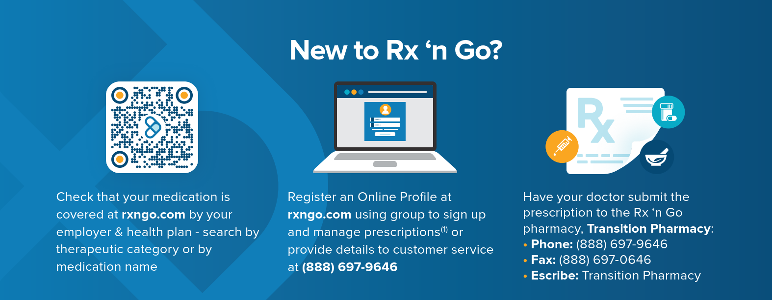**Please note, RX ‘N Go is separate from your medical insurance. If you would like to take advantage of the program, you MUST sign up directly with RX ‘N GO. Registration instructions are listed below.**

**QUESTIONS?** CONTACT CUSTOMER SUPPORT AT

[**rxngo@transitionrx.com**](mailto:rxngo@transitionrx.com) **or (888) 697-6946**

**VIRTUAL PHYSICAL THERAPY – Kaia Health**

When you’re living with sore joints and muscles or recovering from an injury, it can be hard to enjoy life and fulfill all your responsibilities. Kaia is a new virtual exercise therapy program included with your benefit plan to help you enjoy a pain-free life and get back to doing things you need to do and love to do.

**Available at No Cost!**

*Must be enrolled in a UMR medical plan to participate in program.*

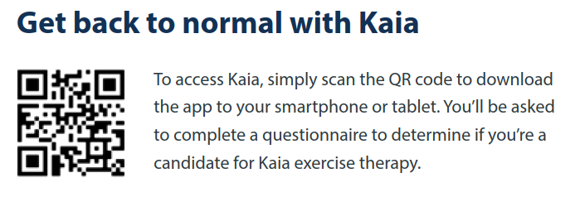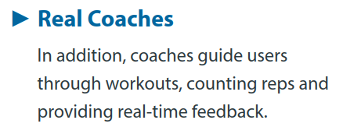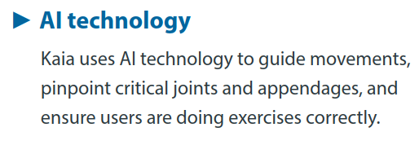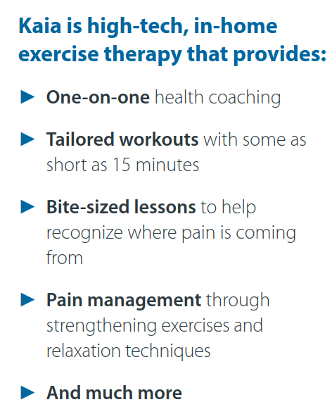

**Dental Coverage is through United Healthcare.**

The chart below provides an overview of your available dental plan. Please refer to your plan document for specific details. *PLEASE NOTE: The Annual Maximum is the MAXIMUM that the plan pays. Once an employee hits this amount, they will be responsible for any remaining claims. Search for dental at* [*www.uhc.com*](https://connect.werally.com/plans/uhc/375)*; network* **National Options PPO 30**

|  |  |  |
| --- | --- | --- |
|  | **Dental Plan PPO** | |
| **Benefits** | **In-Network**  **National Options PPO 30** | **Out-of-Network** |
| **Annual Deductible**  - Individual  - Family | $50  $150 | $50  $150 |
| ***Deductible Waived for Preventive*** | Yes | Yes |
| **Preventive Services**  *Cleanings, Exams, Fluoride, X-rays* | 100% | 100% |
| **Basic Services**  *Fillings, Root Canals, Simple Extractions* | 100% | 80% |
| **Major Services**  *Bridges, Dentures, Implants, Crowns* | 60% | 50% |
| **Annual Maximum** | $1,500 | $1,000 |
| **Orthodontia**  *Under age 19 only* | 60% | 60% |
| **Orthodontia Lifetime Maximum** | $1,000 | $1,000 |

**YOUR COST**

Your payroll deductions are shown below.

|  |  |  |
| --- | --- | --- |
| **BI-WEEKLY EMPLOYEE DEDUCTIONS** | | |
|  | **Employee Only** | **Employee & Family** |
| **Dental Plan** | $3.23 | $12.00 |



**Beginning January 1, 2024. Vision Coverage is through United Healthcare.**

The chart below provides an overview of your available vision plan. Please refer to your plan document for specific details. Search the UnitedHealthcare Vision Network at [myuhcvision.com](http://www.myuhcvision.com) or call (800) 638-3120.

United Healthcare’s vision network includes a national network of eye doctors. Participating locations include Costco Optical, Walmart Vision Center, Target, Sam’s Club, Lenscrafters and Visionworks. United Healthcare also has an exclusive relationship with **Warby Parker**. When using Warby Parker, you can get a pair of glasses for as little as a $25 copay. Visit <https://www.warbyparker.com/united> for more details

|  |  |  |
| --- | --- | --- |
|  | **UHC Vision** | |
| **Benefits** | **In-Network** | **Out-of-Network** |
| **Exam** | $10 Copay | Up to $40 Reimbursement |
| **Frames/Lenses** | $25 Copay, $120 frame allowance | Up to $45 Reimbursement |
| **Elective Contacts** | $25 Copay, $120 contact lens allowance | Up to $120 Reimbursement |
| **Frequency of Services**  Exams  Frames  Lenses OR Contacts | 12 months  24 months  12 months | 12 months  24 months  12 months |



**YOUR COST**

Your payroll deductions are shown below.

|  |  |  |
| --- | --- | --- |
| **BI-WEEKLY EMPLOYEE DEDUCTIONS** | | |
|  | **Employee Only** | **Employee & Family** |
| **Vision Plan** | $2.67 | $5.74 |

**BASIC LIFE AND AD&D INSURANCE – UnitedHealthcare**

Full-time employees receive group life and accidental death and dismemberment (AD&D) insurance. The company pays the full cost of this benefit. Don’t forget to keep your beneficiaries up to date.

**VOLUNTARY LIFE INSURANCE – UnitedHealthcare**  
Employees who want to supplement their group life insurance benefits may purchase additional coverage. When you enroll yourself and/or your dependents in this benefit, you pay the full cost through payroll deductions. You can purchase voluntary life insurance in the increments listed below. Please note, if you waive voluntary life insurance applying for the first time or increasing coverage will require EOI (Evidence of Insurability) or medical underwriting.

|  |  |
| --- | --- |
| **Voluntary Life Insurance** | |
| **Guaranteed Issue** | $150,000 Employee  $50,000 Spouse  $10,000 Children |
| **Employee Coverage** | Increments of $25,000 |
| **Spouse Coverage** | Increments of $5,000; not to exceed 100% of employee amount |
| **Child Coverage** | $10,000; not to exceed 50% of employee amount |

**DISABILITY – UnitedHealthcare**

Full-time employees receive company paid short term disability. Additionally, long term disability can be purchased via payroll deductions. In the event you become disabled from a non-work-related injury or sickness, disability income benefits are provided as a source of income. You are not eligible to receive short-term disability benefits if you are receiving workers’ compensation benefits.

|  |  |  |
| --- | --- | --- |
|  | **Short Term Disability** | **Long Term Disability** |
| **Percentage of Income**  **Replaced** | 66.67% | $1,000 to $7,500 options  *(Must meet minimum salary requirements)* |
| **Benefits Payable** | Up to 13 weeks as long as you remain disabled | Up to Social Security Normal Retirement Age as long as you remain disabled |
| **Benefits Begin** | Day 1 for accident, Day 8 for illness | Day 91 (immediately after short term disability ends) |

**FLEXIBLE SPENDING ACCOUNTS (FSA)**

FSAs provide you with an important tax advantage that can help you pay for expenses on a pre-tax basis. By anticipating your family’s costs for the next year, you can actually lower your taxable income.

You must enroll in your FSA every year to contribute. Your FSA plan options are shown below.

|  |  |
| --- | --- |
| Dependent Care FSA | **Healthcare FSA** |
| Allows employees to use pretax dollars towards qualifying dependent care such as caring for children under age 13 or elders. | Allows employees pay for certain IRS-approved *medical, dental and vision* expenses with pre-tax dollars. |
| **Annual contribution max= $5,000**  (or $2,500 if married and filing separately) | **Annual contribution max= $3,200** |
| Not eligible for roll over monies. | Eligible to roll over $640 into the following year. |

**HEALTH SAVINGS ACCOUNTS (HSA)**

HSAs provide you with an important tax advantage that can help you pay for expenses on a pre-tax basis. By anticipating your family’s costs for the next year, you can actually lower your taxable income.

**You must enroll in the “3200 HSA” medical plan to open a Health Savings Account.**

**When you enroll in the HSA plan, the Company makes a contribution on your behalf.**

|  |
| --- |
| Health Savings Account (HSA) |
| Allows employees pay for certain IRS-approved *medical, dental and vision* expenses with pre-tax dollars. |
| **Annual contribution max= $4,150 individual, $8,300 Family**  **Age 55+ can contribute additional $1,000** |
| Funds are only available to spend as they are deposited in the account. The funds are never forfeited over time and roll over from year to year. You can only fund a health savings account if you are enrolled in an IRS qualified high deductible health plan. |

**EMPLOYEE ASSISTANCE PROGRAM (EAP) – United Healthcare**

The EAP is offered free to all employees and immediate family members. It is a completely confidential counseling program that covers issues such as marital and family concerns, depression, substance abuse, grief and loss, financial entanglements and other personal issues.

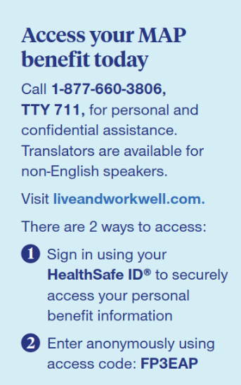

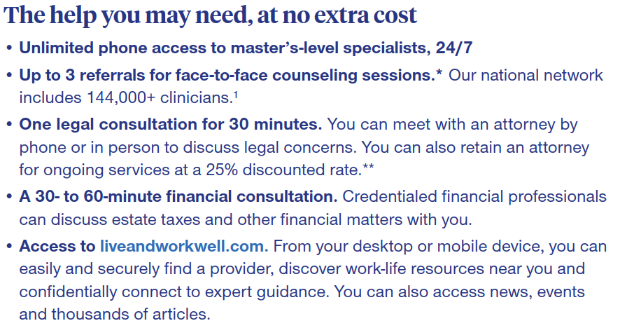

Toll free at 1-877-660-3806, or you can visit their website at [liveworkwell.com.](http://www.liveandworkwell.com) Access Code: **FP3EAP**

**VOLUNTARY ACCIDENT PLAN – United Healthcare**

Accident Insurance pays a lump sum benefit directly to you based on the type of injury sustained and treatment needed. This policy has off the job coverage and includes a **$50 Wellness Benefit** if you receive an eligible screening! For more information on this benefit and its’ rates, please refer to the brochure located at **eselfserve.com.**

**VOLUNTARY CRITICAL ILLNESS INSURANCE – United Healthcare**

Critical Illness pays a lump sum benefit directly to you upon diagnosis of a covered illness after the plan’s effective date of coverage. There are multiple payouts automatically included and a benefit can be paid for each covered condition. Coverage can be taken when you leave the company and includes a **$50 Wellness Benefit** if you receive an eligible screening! For more information on this benefit and its rates, please refer to the brochure at **eselfserve.com.**

**VOLUNTARY HOPSITAL INDEMNITY – United Healthcare**

Hospital Indemnity is an insurance plan that pays cash directly to you. The plan is intended to help with deductible expenses and out of pocket costs associated with a hospital stay and related treatment. This policy includes a **$50 Wellness Benefit** if you receive an eligible screening! For more information on this benefit and its’ rates, please refer to the brochure located at **eselfserve.com.**

**401(k) RETIREMENT PLAN**

The Company offers a 401k retirement plan for its employees. The plan recordkeeper is VOYA. All employees age 20 and older are eligible to participate effective the first of the month after 60 days of employment. The company will provide a matching contribution of 50% of the employee’s contribution up to a maximum of 8%. (If you contribute 8%, the company will match 4%.).

The plan allows for both pretax and Roth after-tax employee contributions. Annual contribution limits are set by the IRS and are subject to change.

If you choose not to enroll by selecting your own contribution percentage and not opt out of the automatic election, you will automatically be enrolled into a Vanguard Target Retirement fund at a 3% deferral rate. You may change your contributions at any time.

Money from other qualified plans is accepted once you have met the plans eligibility requirements.

Employee contributions are 100% vested. Employer Matching Contributions are vested based on years of service:

|  |  |
| --- | --- |
| **Years of Service** | **Vested Percentage** |
| **1 year** | 0% |
| **2 years** | 20% |
| **3 years** | 40% |
| **4 years** | 60% |
| **5 years** | 80% |
| **6 years** | 100% |

**OTHER EMPLOYEE BENEFITS & PERKS**

**Paid Company Holidays & Paid Time Off**

Full time employees are offered company paid holidays and paid time off. Please see the employee handbook for full details.

**Employee Referral Program**

The Company offers a referral bonus to those employees who refer an employee – program details can be found on the Employee Referral Form. The form must be submitted prior to the applicant being offered an interview.

**Employee Discounts**

The Company has partnered with various vendors that offer complimentary perks that give you access to 20 – 60% off on movies, retail, amusement parks, hotels, shows, concerts, sporting events and more!

Tickets At Work: <https://ticketsatwork.com/tickets/account.php?sub=enroll>, Select sign up with Company Code, use “KURTZBROS”

Best Benefits Club: [https://www.bbcmember.com](https://www.bbcmember.com/) – Select Login & Create a New Account, Activation Code: kurtz909

**Boot Reimbursement**

Full time employees, after 90 days, who are required to wear boots as part of their job will be eligible for a Company reimbursement up to $100 per year towards a new pair of boots or repairs to an existing pair of boots. Receipts should be turned into Finance. If you are unsure if your job requires boots, please see your manager.

**Vision Reimbursement**

Full time employees not enrolled in benefits, after 90 days, will be eligible for a Company vision reimbursement up to $100 per year. Receipts should be turned into Finance.

**Professional Certification & Educational Assistance Program**

Full time employees, after one year of service, will be eligible to be reimbursed for obtaining certifications or continuing their education under the following conditions:

Course(s) must relate to employee’s current area of assigned work or provide for future position of advancement within the Company.

Course(s) must be offered by an accredited technical school or university.

Course(s) must be pre-approved by management. Approval forms can be obtained from the Human Resources Department. It is recommended the employee receives the course approval before registering for the course.

Course(s) otherwise paid by scholarships, G.I. benefits, government grants, etc., are not reimbursed.

Note: Certifications, courses and or seminars specifically recommended by management are typically paid for by the company and requires management pre-approval.

**Family Planning Assistance**

Full time employees, after 90 days, are eligible for $500 reimbursement for their families when adopting a child or beginning a family. The Company offers a one-time reimbursement towards the costs (such as legal fees, medications, lab tests, etc.) associated with adoption or fertility therapy. Anyone who is interested in assistance should see the Human Resource Manager for details. Receipts should be turned into Human Resources.

**MARSH & MCLENNAN AGENCY SERVICE TEAM**

This is your dedicated team of employee advocates. They are your primary contact for benefits and enrollment assistance with over 75 years of combined experience. This in-house team is here to clarify benefits, answer eligibility questions, manage claim issues, and much more!

It’s easy to connect with them, call your service team at 412-552-5088

Your employer offers group health plans to some employees and as such is required to distribute certain notices annually to meet compliance guidelines.

**Kurtz Bros, Inc.** will herein be referred to as “Employer”

UMR will herein be referred to as “Medical Plan(s)”

Kurtz Bros, Inc. will herein be referred to as “Plan Administrator”

You can contact your Plan Administrator at *216-986-7000*

***The attached legal notices packet includes certain legal notices applicable to most employers that offer health and welfare benefit plans.  We have prepared this packet for you based on our knowledge of your benefits as our client and our understanding of the notices requirements as a broker in the insurance industry and not as legal or tax advice.  These notices may require certain modifications to fit your exact circumstances in order to fulfill your legal obligations.  There may also be other legal notices applicable to you that are not included within this packet.  We recommend you review these notices with your legal counsel prior to distributing them to your employees and plan participants, and we are happy to assist you and/or your legal counsel with this review process.*IMPORTANT NOTICE FROM YOUR EMPLOYER ABOUT YOUR PRESCRIPTION DRUG COVERAGE AND MEDICARE**

Please read this notice carefully and keep it where you can find it. This notice has information about your current prescription drug coverage with your Employer and about your options under Medicare’s prescription drug coverage. This information can help you decide whether or not you want to join a Medicare drug plan. If you are considering joining, you should compare your current coverage, including which drugs are covered at what cost, with the coverage and costs of the plans offering Medicare prescription drug coverage in your area. Information about where you can get help to make decisions about your prescription drug coverage is at the end of this notice.

There are two important things you need to know about your current coverage and Medicare’s prescription drug coverage:

1. Medicare prescription drug coverage became available in 2006 to everyone with Medicare. You can get this coverage if you join a Medicare Prescription Drug Plan or join a Medicare Advantage Plan (like an HMO or PPO) that offers prescription drug coverage. All Medicare drug plans provide at least a standard level of coverage set by Medicare. Some plans may also offer more coverage for a higher monthly premium.
2. Your Employer has determined that the prescription drug coverage offered by the Medical Plan(s) is, on average for all plan participants, expected to pay out as much as standard Medicare prescription drug coverage pays and is therefore considered **Creditable Coverage.** Because your existing coverage is Creditable Coverage, you can keep this coverage and not pay a higher premium (a penalty) if you later decide to join a Medicare drug plan.

**When Can You Join A Medicare Drug Plan?**

You can join a Medicare drug plan when you first become eligible for Medicare and each year from October 15th to December 7th. However, if you lose your current creditable prescription drug coverage, through no fault of your own, you will also be eligible for a two (2) month Special Enrollment Period (SEP) to join a Medicare drug plan.

**What Happens To Your Current Coverage If You Decide to Join A Medicare Drug Plan?**

If you decide to join a Medicare drug plan while enrolled in your Employer’s coverage as an active employee, please note that your Employer’s coverage will be the primary payer for your prescription drug benefits and Medicare will pay secondary. As a result, the value of your Medicare prescription drug benefits will be significantly reduced. Medicare will usually pay primary for your prescription drug benefits if you participate in your Employer’s coverage as a former employee.

You may also choose to drop your Employer’s coverage. If you do decide to join a Medicare drug plan and drop your current your Employer’s coverage, be aware that you and your dependents may not be able to get this coverage back.

**When Will You Pay A Higher Premium (Penalty) To Join A Medicare Drug Plan?**

You should also know that if you drop or lose your current coverage with your Employer’s and don’t join a Medicare drug plan within 63 continuous days after your current coverage ends, you may pay a higher premium (a penalty) to join a Medicare drug plan later.

If you go 63 continuous days or longer without creditable prescription drug coverage, your monthly premium may go up by at least 1% of the Medicare base beneficiary premium per month for every month that you did not have that coverage. For example, if you go nineteen months without creditable coverage, your premium may consistently be at least 19% higher than the Medicare base beneficiary premium. You may have to pay this higher premium (a penalty) as long as you have Medicare prescription drug coverage. In addition, you may have to wait until the following October to join.

**For More Information About This Notice Or Your Current Prescription Drug Coverage…**

Contact the person listed below for further information NOTE: You’ll get this notice each year. You will also get it before the next period you can join a Medicare drug plan, and if this coverage through your Employer changes. You also may request a copy of this notice at any time.

**For More Information About Your Options Under Medicare Prescription Drug Coverage…**

More detailed information about Medicare plans that offer prescription drug coverage is in the “Medicare & You” handbook. You’ll get a copy of the handbook in the mail every year from Medicare. You may also be contacted directly by Medicare drug plans.

For more information about Medicare prescription drug coverage:

* Visit [www.medicare.gov](http://www.medicare.gov)
* Call your State Health Insurance Assistance Program (see the inside back cover of your copy of the “Medicare & You” handbook for their telephone number) for personalized help
* Call 1-800-MEDICARE (1-800-633-4227). TTY users should call 1-877-486-2048.

If you have limited income and resources, extra help paying for Medicare prescription drug coverage is available. For information about this extra help, visit Social Security on the web at [www.socialsecurity.gov](http://www.socialsecurity.gov), or call them at 1-800-772-1213 (TTY 1-800-325-0778).

**Remember: Keep this Creditable Coverage notice. If you decide to join one of the Medicare drug plans, you may be required to provide a copy of this notice when you join to show whether or not you have maintained creditable coverage and, therefore, whether or not you are required to pay a higher premium (a penalty).**

Date: November 2023

Name of Entity/Sender: Kurtz Bros, Inc.

Contact--Position/Office: Human Resources

Address: 6415 Granger Rd. Independence, OH 44131

Phone Number: 216-986-7000

**WOMEN’S HEALTH AND CANCER RIGHTS ACT**

If you have had or are going to have a mastectomy, you may be entitled to certain benefits under the Women’s Health and Cancer Rights Act of 1998 (WHCRA). For individuals receiving mastectomy-related benefits, coverage will be provided in a manner determined in consultation with the attending physician and the patient, for:

* all stages of reconstruction of the breast on which the mastectomy was performed;
* surgery and reconstruction of the other breast to produce a symmetrical appearance;
* prostheses; and
* treatment of physical complications of the mastectomy, including lymphedema.

These benefits will be provided subject to the same deductibles and coinsurance applicable to other medical and surgical benefits provided under this plan. Therefore, the Deductible and the Coinsurance applies.

If you would like more information on WHCRA benefits, call your Plan Administrator.

**NEWBORNS’ AND MOTHERS’ HEALTH PROTECTION ACT ENROLLMENT NOTICE**

Group health plans and health insurance issuers generally may not, under federal law, restrict benefits for any hospital length of stay in connection with childbirth for the mother or newborn child to less than 48 hours following a vaginal delivery, or less than 96 hours following a cesarean section. However, federal law generally does not prohibit the mother's or newborn's attending provider, after consulting with the mother, from discharging the mother or her newborn earlier than 48 hours (or 96 hours as applicable). In any case, plans and issuers may not, under federal law, require that a provider obtain authorization from the plan or the issuer for prescribing a length of stay not in excess of 48 hours (or 96 hours).

**HIPAA NOTICE OF PRIVACY PRACTICES**

The Employer’s Group Health Plan maintains a Notice of Privacy Practices that provides information to individuals whose protected health information (PHI) will be used or maintained by the Plan. If you would like a copy of the Plan’s Notice of Privacy Practices, please contact your Plan Administrator.

**HIPAA SPECIAL ENROLLMENT RIGHTS NOTICE**

If you are declining enrollment for yourself or your dependents (including your spouse) because of other health insurance or group health plan coverage, you may be able to enroll yourself and your dependents in this plan if you or your dependents lose eligibility for that other coverage (or if the employer stops contributing towards your or your dependents' other coverage). However, you must request enrollment within 30 days after your or your dependents' other coverage ends (or after the employer stops contributing toward the other coverage).

If you have a new dependent as a result of marriage, birth, adoption, or placement for adoption, you may be able to enroll yourself and your dependents. However, you must request enrollment within 30 days after the marriage, birth, adoption, or placement for adoption.

If you decline enrollment for yourself or for an eligible dependent (including your spouse) while Medicaid coverage or coverage under a state children's health insurance program is in effect, you may be able to enroll yourself and your dependents in this plan if you or your dependents lose eligibility for that other coverage. However, you must request enrollment within 60 days after your or your dependents' coverage ends under Medicaid or a state children's health insurance program.

If you or your dependents (including your spouse) become eligible for a state premium assistance subsidy from Medicaid or through a state children's health insurance program with respect to coverage under this plan, you may be able to enroll yourself and your dependents in this plan. However, you must request enrollment within 60 days after your or your dependents' determination of eligibility for such assistance.

To request special enrollment or obtain more information, contact your Plan Administrator.

**PREMIUM ASSISTANCE UNDER MEDICAID AND THE CHILDREN’S HEALTH INSURANCE PROGRAM (CHIP)**

If you or your children are eligible for Medicaid or CHIP and you’re eligible for health coverage from your employer, your state may have a premium assistance program that can help pay for coverage, using funds from their Medicaid or CHIP programs. If you or your children aren’t eligible for Medicaid or CHIP, you won’t be eligible for these premium assistance programs but you may be able to buy individual insurance coverage through the Health Insurance Marketplace. For more information, visit [**www.healthcare.gov**](http://www.healthcare.gov).

If you or your dependents are already enrolled in Medicaid or CHIP and you live in a State listed below, contact your State Medicaid or CHIP office to find out if premium assistance is available.

If you or your dependents are NOT currently enrolled in Medicaid or CHIP, and you think you or any of your dependents might be eligible for either of these programs, contact your State Medicaid or CHIP office or dial **1-877-KIDS NOW** or [**www.insurekidsnow.gov**](http://www.insurekidsnow.gov) to find out how to apply. If you qualify, ask your state if it has a program that might help you pay the premiums for an employer-sponsored plan.

If you or your dependents are eligible for premium assistance under Medicaid or CHIP, as well as eligible under your employer plan, your employer must allow you to enroll in your employer plan if you aren’t already enrolled. This is called a “special enrollment” opportunity, and **you must request coverage within 60 days of being determined eligible for premium assistance**. If you have questions about enrolling in your employer plan, contact the Department of Labor at [**www.askebsa.dol.gov**](http://www.askebsa.dol.gov) or call **1-866-444-EBSA** **(3272)**.

**If you live in one of the following states, you may be eligible for assistance paying your employer health plan premiums. The following list of states is current as of July 31, 2023. Contact your State for more information on eligibility –**

|  |  |
| --- | --- |
| **ALABAMA – Medicaid** | **CALIFORNIA – Medicaid** |
| Website: <http://myalhipp.com/>  Phone: 1-855-692-5447 | Website:  Health Insurance Premium Payment (HIPP) Program  <http://dhcs.ca.gov/hipp>  Phone: 916-445-8322  Fax: 916-440-5676  Email: [hipp@dhcs.ca.gov](mailto:hipp@dhcs.ca.gov) |
| **ALASKA – Medicaid** | **COLORADO – Health First Colorado (Colorado’s Medicaid Program) & Child Health Plan Plus (CHP+)** |
| The AK Health Insurance Premium Payment Program  Website: <http://myakhipp.com/>  Phone: 1-866-251-4861  Email: [CustomerService@MyAKHIPP.com](mailto:CustomerService@MyAKHIPP.com)  Medicaid Eligibility: <http://dhss.alaska.gov/dpa/Pages/medicaid/default.aspx> | Health First Colorado Website: <https://www.healthfirstcolorado.com/>  Health First Colorado Member Contact Center:  1-800-221-3943/ State Relay 711  CHP+: <https://www.colorado.gov/pacific/hcpf/child-health-plan-plus>  CHP+ Customer Service: 1-800-359-1991/ State Relay 711  Health Insurance Buy-In Program (HIBI):  <https://www.colorado.gov/pacific/hcpf/health-insurance-buy-program>  HIBI Customer Service:  1-855-692-6442 |
| **ARKANSAS – Medicaid** | **FLORIDA – Medicaid** |
| Website: <http://myarhipp.com/>  Phone: 1-855-MyARHIPP (855-692-7447) | Website: <https://www.flmedicaidtplrecovery.com/flmedicaidtplrecovery.com/hipp/index.html>  Phone: 1-877-357-3268 |
| **GEORGIA – Medicaid** | **MAINE – Medicaid** |
| A HIPP Website: [https://medicaid.georgia.gov/health-insurance-premium-payment-program-hipp](https://gcc01.safelinks.protection.outlook.com/?url=https%3A%2F%2Fmedicaid.georgia.gov%2Fhealth-insurance-premium-payment-program-hipp&data=02%7C01%7Cstashlaw%40dch.ga.gov%7C98b18a96ce1b49d087f708d709449652%7C512da10d071b4b948abc9ec4044d1516%7C0%7C0%7C636988062560854968&sdata=7rziGawQfBKcW1N2%2Bdi2j8cyHpaCYURGdtF8Hk%2By6FM%3D&reserved=0)  Phone: 678-564-1162, Press 1  GA CHIPRA Website:  <https://medicaid.georgia.gov/programs/third-party-liability/childrens-health-insurance-program-reauthorization-act-2009-chipra>  Phone: (678) 564-1162, Press 2 | Enrollment Website: <https://www.maine.gov/dhhs/ofi/applications-forms>  Phone: 1-800-442-6003  TTY: Maine relay 711  Private Health Insurance Premium Webpage: <https://www.maine.gov/dhhs/ofi/applications-forms> Phone: -800-977-6740.  TTY: Maine relay 711 |
| **INDIANA – Medicaid** | **MASSACHUSETTS – Medicaid and CHIP** |
| Healthy Indiana Plan for low-income adults 19-64  Website: <http://www.in.gov/fssa/hip/>  Phone: 1-877-438-4479  All other Medicaid  Website: https://www.in.gov/medicaid/  Phone 1-800-457-4584 | Website: <https://www.mass.gov/masshealth/pa>  Phone: 1-800-862-4840 |
| **IOWA – Medicaid and CHIP (Hawki)** | **MINNESOTA – Medicaid** |
| Medicaid Website:  <https://dhs.iowa.gov/ime/members> Medicaid Phone: 1-800-338-8366  Hawki Website:  <http://dhs.iowa.gov/Hawki>  Hawki Phone: 1-800-257-8563  HIPP Website: <https://dhs.iowa.gov/ime/members/medicaid-a-to-z/hipp>  HIPP Phone: 1-888-346-9562 | Website:  [https://mn.gov/dhs/people-we-serve/children-and-](https://mn.gov/dhs/people-we-serve/children-and-families/health-care/health-care-programs/programs-and-services/other-insurance.jsp) [families/health-care/health-care-programs/programs-and-](https://mn.gov/dhs/people-we-serve/children-and-families/health-care/health-care-programs/programs-and-services/other-insurance.jsp) [services/other-insurance.jsp](https://mn.gov/dhs/people-we-serve/children-and-families/health-care/health-care-programs/programs-and-services/other-insurance.jsp)  Phone: 1-800-657-3739 |
| **KANSAS – Medicaid** | **MISSOURI – Medicaid** |
| Website: https://www.kancare.ks.gov/  Phone: 1-800-792-4884 | Website:  <http://www.dss.mo.gov/mhd/participants/pages/hipp.htm> Phone: 573-751-2005 |
| **KENTUCKY – Medicaid** | **MONTANA – Medicaid** |
| Kentucky Integrated Health Insurance Premium Payment Program (KI-HIPP) Website:  <https://chfs.ky.gov/agencies/dms/member/Pages/kihipp.aspx>  Phone: 1-855-459-6328  Email: [KIHIPP.PROGRAM@ky.gov](mailto:KIHIPP.PROGRAM@ky.gov)  KCHIP Website: <https://kidshealth.ky.gov/Pages/index.aspx>  Phone: 1-877-524-4718  Kentucky Medicaid Website: <https://chfs.ky.gov> | Website:  <http://dphhs.mt.gov/MontanaHealthcarePrograms/HIPP> Phone: 1-800-694-3084 |
| **LOUISIANA – Medicaid** | **NEBRASKA – Medicaid** |
| Website: [www.medicaid.la.gov](http://dhh.louisiana.gov/index.cfm/subhome/1/n/331) or [www.ldh.la.gov/lahipp](http://www.ldh.la.gov/lahipp)  Phone: 1-888-342-6207 (Medicaid hotline) or 1-855-618-5488 (LaHIPP) | Website: [http://www.ACCESSNebraska.ne.gov](http://www.accessnebraska.ne.gov/) Phone: 1-855-632-7633  Lincoln: 402-473-7000  Omaha: 402-595-1178 |
| **NEVADA – Medicaid** | **SOUTH CAROLINA – Medicaid** |
| Medicaid Website: [http://dhcfp.nv.gov](http://dhcfp.nv.gov/) Medicaid Phone: 1-800-992-0900 | Website: [https://www.scdhhs.gov](https://www.scdhhs.gov/)  Phone: 1-888-549-0820 |
| **NEW HAMPSHIRE – Medicaid** | **SOUTH DAKOTA – Medicaid** |
| Website: <https://www.dhhs.nh.gov/oii/hipp.htm>  Phone: 603-271-5218  Toll free number for the HIPP program: 1-800-852-3345, ext 5218 | Website: [http://dss.sd.gov](http://dss.sd.gov/)  Phone: 1-888-828-0059 |
| **NEW JERSEY – Medicaid and CHIP** | **TEXAS – Medicaid** |
| Medicaid Website:  [http://www.state.nj.us/humanservices/](http://www.state.nj.us/humanservices/dmahs/clients/medicaid/) [dmahs/clients/medicaid/](http://www.state.nj.us/humanservices/dmahs/clients/medicaid/)  Medicaid Phone: 609-631-2392  CHIP Website: <http://www.njfamilycare.org/index.html> CHIP Phone: 1-800-701-0710 | Website: <http://gethipptexas.com/>  Phone: 1-800-440-0493 |
| **NEW YORK – Medicaid** | **UTAH – Medicaid and CHIP** |
| Website: <https://www.health.ny.gov/health_care/medicaid/>  Phone: 1-800-541-2831 | Medicaid Website: <https://medicaid.utah.gov/>  CHIP Website: <http://health.utah.gov/chip>  Phone: 1-877-543-7669 |
| **NORTH CAROLINA – Medicaid** | **VERMONT – Medicaid** |
| Website: <https://medicaid.ncdhhs.gov/>  Phone: 919-855-4100 | Website: <http://www.greenmountaincare.org/>  Phone: 1-800-250-8427 |
| **NORTH DAKOTA – Medicaid** | **VIRGINIA – Medicaid and CHIP** |
| Website: <http://www.nd.gov/dhs/services/medicalserv/medicaid/>  Phone: 1-844-854-4825 | Website: <https://www.coverva.org/en/famis-select> <https://www.coverva.org/en/hipp>  Medicaid Phone:1-800-432-5924  CHIP Phone:1-800-432-5924 |
| **OKLAHOMA-Medicaid and CHIP** | **WASHINGTON – Medicaid** |
| Website: [http://www.insureoklahoma.org](http://www.insureoklahoma.org/)  Phone: 1-888-365-3742 | Website: <https://www.hca.wa.gov/>  Phone: 1-800-562-3022 |
| **OREGON – Medicaid** | **WEST VIRGINIA – Medicaid and CHIP** |
| Website: <http://healthcare.oregon.gov/Pages/index.aspx>  <http://www.oregonhealthcare.gov/index-es.html> Phone: 1-800-699-9075 | Website: <https://dhhr.wv.gov/bms/>  <http://mywvhipp.com/>  Medicaid Phone: 304-558-1700  CHIP Toll-free phone: 1-855-MyWVHIPP (1-855-699- 8447) |
| **PENNSYLVANIA – Medicaid** | **WISCONSIN – Medicaid and CHIP** |
| Website:  <https://www.dhs.pa.gov/Services/Assistance/Pages/HIPP-Program.aspx>  Phone: 1-800-692-7462 | Website:  [https://www.dhs.wisconsin.gov/badgercareplus/p-](https://www.dhs.wisconsin.gov/badgercareplus/p-10095.htm) [10095.htm](https://www.dhs.wisconsin.gov/badgercareplus/p-10095.htm)  Phone: 1-800-362-3002 |
| **RHODE ISLAND – Medicaid and CHIP** | **WYOMING – Medicaid** |
| Website: <http://www.eohhs.ri.gov/>  Phone: 1-855-697-4347, or 401-462-0311 (Direct RIte  Share Line) | Website: <https://health.wyo.gov/healthcarefin/medicaid/programs-and-eligibility/>  Phone: 1-800-251-1269 |

To see if any other states have added a premium assistance program since July 31, 2023, or for more information on special enrollment rights, contact either:

U.S. Department of Labor U.S. Department of Health and Human Services

Employee Benefits Security Administration Centers for Medicare & Medicaid Services

[**www.dol.gov/agencies/ebsa**](https://www.dol.gov/agencies/ebsa)[**www.cms.hhs.gov**](http://www.cms.hhs.gov/)

1-866-444-EBSA (3272) 1-877-267-2323, Menu Option 4, Ext. 61565